CURRICULUM VITAE

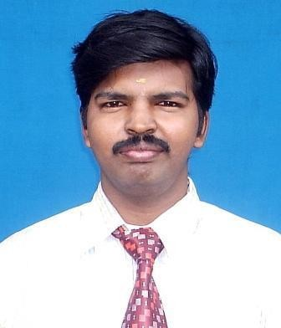
PERSONAL PROFILE :

Name : S.BALAMURUGAN
Date of Birth : 17.04.1984
Blood Group : O +
Contact Address : NO: 234,23rd Cross Street, Nolambur, Chennai-600 037.
Chennai – 600 011.
Mobile : 9941236226
E-mail : sbm.eee@rmkec.ac.in sbala_1704@yahoo.co.in
WORKING EXPERIENCE :
( 12 years of teaching experience )

Presently working as Assistant Professor(Grade-II) in RMK Engineering College, , Kavaraipettai, (From June 2011 to till date )
Previously worked as Lecturer and HOD I/C in Magna College of Engineering, Thiruvallur High road , Chennai – 55. (From 01.8.2006 to 31.05.2011 - 4.8 years of teaching experience )

EDUCATIONAL PROFILE :
- Done ME – Power systems Engineering in College of Engineering, Anna University during the year 2006 - 2009 with first class.

- Done BE – Electrical and Electronics Engineering, S.A Engineering College during the year 2001 – 2005 with first class.
- Completed XII – Southern pearl Matriculation Higher secondary school ( Now Velammal MHSS),Mogappair
- Completed X- Sri Rajalakshmi Matriculation Higher secondary school
CONTRIBUTIONS :
- Worked as HoD– in – charge for 2years (Dec 2008 – April 2011 ) in Magna college of Engineering
- As Department Placement coordinator during 2012-2013 in RMK Engineering College.
- As website coordinator, class In-charge, Student Counselor.
- Arranged various Guest Lectures Events.

SUBJECTS HANDLED:

Theory subjects
Circuit Theory, Basic Electrical and Electronics Engineering, Measurements and Instrumentation, Control systems, Power Electronics, Protection and switchgear, Power system analysis, Power system operation and control, Electronics devices and circuits, Electric energy generation, utilization and conservation , Principles of management, Total Quality Management

Practical subjects
Engineering Practices Lab, Control systems Lab, Measurements and Instrumentation, Electronics Lab, Power Electronics Lab, Power system simulation Lab.

SEMINARS / WORKSHOPS/CONFERENCES ATTENDED :
  - Attended Two days conclave on “DESIGN EDUCATION FOR CREATING VALUES AND DRIVING BUSINESS GROWTH” organized by SAE INDIA on from 19-02-2018 & 20-02-2018. at IIT Madras.
  - Attended Seven days Anna University sponsored FDTP on “Power systems operation and control” from 9-12-2016 to 16-12-2016. at RMK Engineering College
  - Attended Seven days Anna University sponsored FDTP on “Transmission and Distribution “ from 27-11-2017 to 04-12-2017. at RMD Engineering College
  - Attended AICTE sponsored Two Days Workshop on “Renewable Energy For Smart Grid”at Velammal Engineering College on 07-12-2017and 08-12-2017
  - Attended AICTE sponsored FDTP on “Soft computing techniques in power converters using MATLAB & PSCAD” at Velammal Engineering College on 29-10-2016 and 30-10-2016.
- Two days workshop on “Modern power system Analysis tools” conducted by Anna University
- One day FDTP on “Knowledge Development”conducted by Tata Consultancy Services” on 06-07-2015
  - Published paper on “Development Of Regenerative Breaking Concept For Electrical Vehicles Enhanced With Half Bridge Converter” in International Journal of Innovative Research in Science, Engineering and Technology on 04-04-2018
  - Published paper on “Implementation of Fan ON/OFF Control Using Internet of Things for Home Automation in International Journal of Innovative Research in Science, Engineering and Technology on 25-02-2018
  - Presented Paper in International Conference in at Sri Venkateswara college of Engineering & technology titled ““Design of predictive control of active power filter using four leg inverter with improved performance for solar energy generation system” March 2015
  - Presented Paper in International Conference in Magna college of Engineering titled “Load shedding strategies for relaxation of optimum Reactive power” in April 2011.
  - Presented Paper in National Conference in Mahendra Engineering college titled “Optimum relaxation of reactive power by load shedding” in April 2009.

I hereby declare that the above furnished information is true to the best of my knowledge and belief

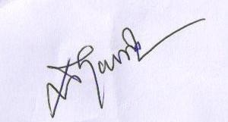
(S.BALAMURUGAN)

